The Chicago Board Options Exchange—
Operations and Help Desk Tools

Functional Requirements

Prepared by: Karen N. Christiansen
Level 1Review by: Terry Land, Mike Todd, Curt Schumacher
Version: 1.0
Status: Draft
Date: 7/30/2003

1 Document History 3
2 Introduction 4
2.1 History 4
2.2 Approach 4
2.3 Scope Note 4
3 System Health Monitor 5
3.1 System Health Monitor 5
3.2 Adapter Monitor 9
4 Infrastructure Monitor 11
4.1 Node List 11
4.2 Network View 13
5 CAS/User Monitor 14
5.1 CAS Monitor 14
5.2 Thread Usage 15
5.3 Display Current CAS Properties 16
5.4 User Queue Monitor 17
5.5 User Callback Monitor 18
5.6 User Detail Monitor 18
5.7 CAS Control 19
6 SA GUI Enhancements 20
6.1 Display Orders 20
6.2 Cancel Event Logging Enhancements 20
6.3 Trade Modification 21
6.4 Trading Properties Screen 21

Document History

Version | Date | Author | Reason
0.1 | April 24, 2003 | Karen Christiansen | Initial Draft.
0.2 | May 12, 2003 | Karen Christiansen | Includes update from CAS team.
0.3 | May 20, 2003 | Karen Christiansen | Modified to reflect design approach.
0.4 | May 30, 2003 | Karen Christiansen | Added Business Cluster and Adapter screens.
0.5 | June 2, 2003 | Karen Christiansen | Modified Screens for Adapter Monitors.
0.6 | June 9, 2003 | Karen Christiansen | Modified to incorporate Operations feedback.
0.7 | June 18, 2003 | Karen Christiansen | Included Infrastructure Monitoring tool. Modified to include tree view of Systems Health Monitor.
0.8 | June 25, 2003 | David Jedeikin | Modified screen shots.
0.9 | July 3, 2003 | Karen Christiansen | Incorporated final Operations comments.
1.0 | July 30, 2003 | Karen Christiansen | Updated requirements for SA GUI order cancel enhancements

Introduction

History
On October 26, 2001, the CBOE launched its screen-based trading system, CBOEdirect, for trading equity index products during extended trading hours. On November 8, 2002, a second trading session was added to support the OneChicago security futures exchange. In the second quarter of 2003, CBOE will launch the Hybrid Trading System, with CBOEdirect becoming the book for selected equity classes during regular trading hours.

As usage of the CBOEdirect system has increased, the need for comprehensive and efficient system management tools has also increased. The purpose of this document is to outline the requirements for delivering functionality that will improve the management, control and error troubleshooting capabilities of the CBOEdirect system, and its interfaces with related CBOE systems.

Approach
Systems Development and Operations have identified the high priority monitoring and management tools that are required to provide effective and efficient management of the CBOEdirect system. These tools will be provided by two separate applications, having a similar look and feel. Separate workstations will not be required to support each application. However, it is believed that from a practical standpoint, Operations would want to display each of these applications on a separate monitor in the manned data center. The following applications will be developed:

- System Health Monitor
- Adapter Monitor
- Infrastructure Monitor
- CAS/User Monitor

In order to provide more efficient management of the electronic market, certain enhancements to the SA GUI, used by the Help Desk will also be provided.

The functionality provided by each of these applications is described in this document.

Scope Note
In gathering the requirements for these tools from CBOE Systems Operations, certain limitations of the Fixometer were identified. CBOE Systems Development is currently working with Javelin to resolve this issues. Requirements to enhance and/or replace the current Fixometer are outside the scope of these requirements.

In addition, a separate effort will identify the opportunities to make the end of session processing for CBOEdirect more efficient.

System Health Monitor
The purpose of the System Health Monitor is to provide CBOE Operations staff with the ability to view the status, health and activity of all components and processes related to the CBOEdirect system. By using this tool, Operations will have the ability to query status and receive alerts for immediate response situations.

The GUI will provide a search function, to enable Operations to quickly locate a specific component. This will be particularly useful when searching for status and message counts for a particular CAS. Operations will be able to sort any desired column by clicking on the appropriate column heading.

Color will be used to designate the health of each component:

Color | Status | Traffic
Green | Up | Flowing
Yellow | Up | Not Flowing
Orange | Down, Not Reachable | Not Flowing
Red | Down, Reachable | Not Flowing

System Health Monitor

A GUI will be provided that allows Operations to monitor and manage the various components of the CBOEdirect architecture. Operations will be able to view the following components:

- CASs
- Front Ends
- Business Clusters
- Global Clusters
- Linkage Server

For each of these components, the tool will display the name of the component, the status of the component, message counts in, rate in, message counts out and rate out. The tool could also be configured to provide any data available through ComPath (Messages lost and/or ignored; blocks sent, received, lost and/or ignored; bytes sent, received, lost and/or ignored; average message lost rate, average message ignore rate; average block send rate; average block receive rate; average block lost rate; average block ignore rate; peak block send rate; peak block receive rate; peak block lost rate, peak block ignore rate; average byte send rate; average byte receive rate; average byte lost rate; average byte ignore rate; peak byte send rate; peak byte receive rate; peak byte lost rate; peak byte ignore rate; peak queue depth; average transaction time; and peak transaction time.

Critical processes will be identified to determine the status of the components. If all processes defined as critical are running, the status “Up” will be displayed for hat component. If any processes defined as critical are not running, the component status will be “down”. For components which have a master or slave status, when the status is “Up”, the status column will display the master/slave status for that component.

Data will be displayed in a tree view. Beneath each high level component, each instance of that component will be displayed. Beneath each instance of the component, all of the processes running on that component will display. Beneath each process, every method for that process will be displayed. For all displayed items, users will be able to view the status, message counts and rates.

Operations will have the ability to determine what level at which they want to view System Health data by selecting which levels of the tree to view. A scroll bar will be provided if the amount of data selected to view exceeds the height of the window.

The system will update data automatically every n (30) seconds. The GUI will include a refresh button that will allow Operations to refresh the screen at will. A throttle will be applied to the use of this refresh button to prevent a user from overwhelming the system will repetitive refresh requests.

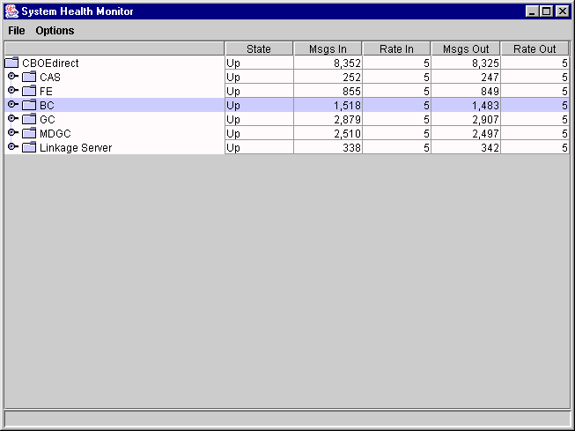
System Health Monitor rolled up to the base container level.
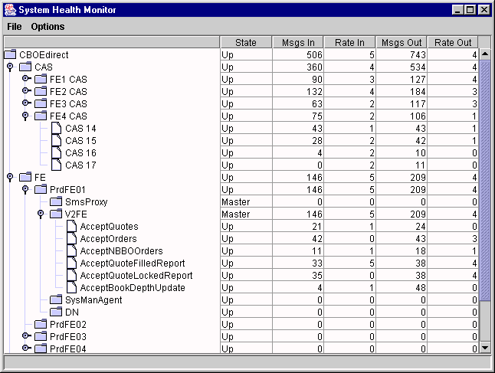
System Health Monitor expanded to provide detailed view of Front Ends¹
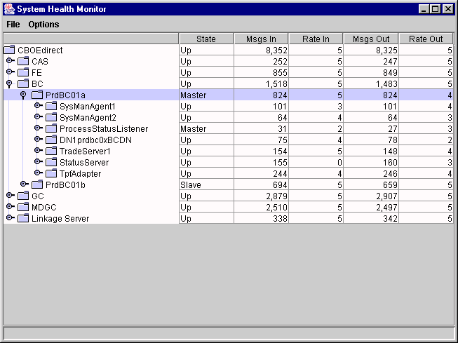
System Health Monitor expanded to provide process view of Business Clusters¹

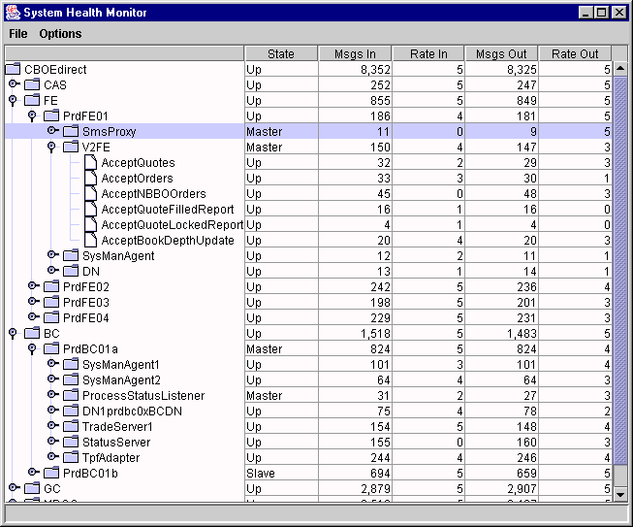
System Health Monitor expanded to provide detailed view of Front Ends and Business Cluster¹

Adapter Monitor

The Adapter Monitor will provide Operations with a display of the status and message counts of each of the Adapter Services running for each of the CBOEdirect external adapters. The following information will be displayed:

- Adapter Name (TPF, TiPS, COPP, CTM, and Membership)
- Container Name (e.g., BC1A)
- Status
- Message Counts In
- Message Counts Out
- Last Status Time

In cases in which there are multiple instances of the same adapter, each instance will be displayed. Message counts “In” will count the number of messages sent by the adapter into CBOEdirect. Message counts “Out” will count the number of messages sent by CBOEdirect into the adapter.

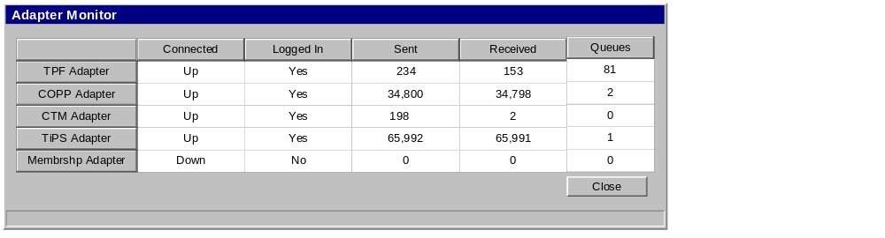Adapter Monitor

Infrastructure Monitor
The Infrastructure Monitor will be developed to allow Operations and Infrastructure Support to monitor messages at the Infrastructure level. In a subsequent release of the Infrastructure Monitor, functionality could be provided to allow Infrastructure management tasks to be executed.

Node List
From the Message Monitor, the user will be able to request a Node List. A generic view will be available. Additionally, users will have the ability to save a preference set that would include environment connection information and other relevant data.

The generic window of the Node List will display all the of connected nodes in the system. Users will have the ability to filter the display by Node Type. Selections for this filter will include:
- Distribution Nodes
- Front Ends
- Global Clusters or Business Clusters only
- CASs only
- All but Distribution Nodes.

In addition, the user will be able to filter by channel. The user will be able to sort the display alphabetically, by host, by type or by status by selecting the appropriate radio button.

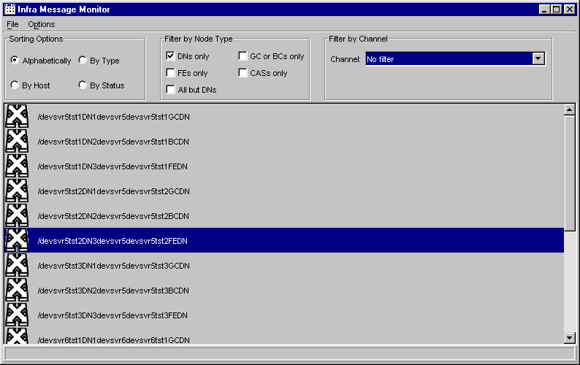

By right clicking on one of the nodes in the list, a menu will display. From this menu, users will be able view communications data grouped by channel or subject, initiate a poll (update) of the particular client’s information, view the general properties of the node, or remove the node from the list.
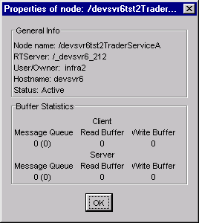

The general properties of the Node detailed in the window above includes the following information: what Talarian RT server the node is connected to, what User ID it is executing under, what host (machine) it is executing on and what its Talarian status is, i.e., does the RT Server consider this a participating node.

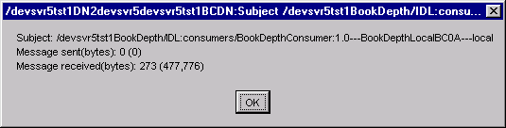

When the user selects a subject to monitor, the non-modal window above will be displayed. The user will be able to keep this window on the screen while performing other activities within the Infrastructure Monitor. The numbers within this window will update dynamically as activity occurs in the node. The user can monitor several subjects simultaneously.

Network View
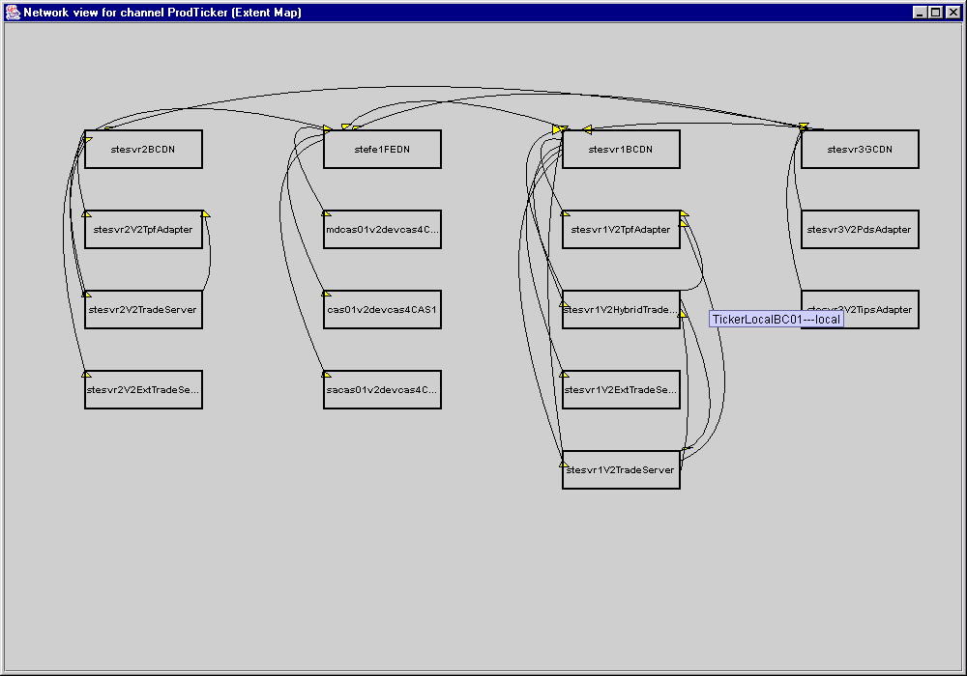

The above window shows the extent map view within the Network Monitor. The entire network is too complex to render at once; the user will be able to view a channel at a time. In addition to viewing the extent name, additional information about the link will be available.

The tool will provide a “live” view of the network to show how it is actually communicating, not just how it is configured to communicate. By overlaying the live view with the extent map, Operations and Support will be able to obtain a clear view of configuration problems.

CAS/User Monitor

The purpose of the CAS/User viewer is to provide CBOE Operations staff with the ability to view the status, health and activity of CAS’s and Users connected to the CBOEdirect system. By using this tool, Operations will have the ability to query status and receive alerts for immediate response situations.

This GUI will display all of the CAS’s that have been deployed and connected to the CBOEdirect production environment. This GUI will display the CAS’s according to the naming conventions known to Operations (i.e., CAS5).

The GUI will provide a search function, to enable Operations to quickly locate a specific component. This will be particularly useful when searching for status and message counts for a particular CAS. Operations will be able to sort any desired column by clicking on the appropriate column heading.

The CAS Monitor will request data to display every (n) 30 seconds. When displaying updated information, the GUI will refresh only the field that changed. The entire screen will not be refreshed when an update occurs. A refresh button will be provided to allow the user to request a refresh. A throttle will be placed on the refresh button to prevent the user from overwhelming the system with repeated refresh requests.

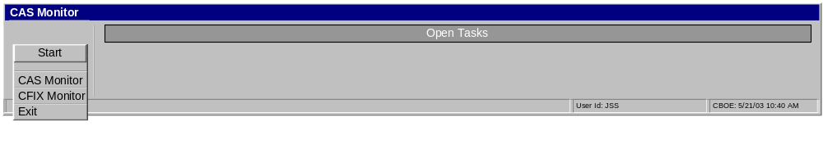Main Taskbar

CAS Monitor
The starting point for the CAS Monitor application is this screen, displays the health of each CAS connected to CBOEdirect. For each CAS enabled in CBOEdirect, the GUI will display:

- CAS Name
- Name of the entity connected to the CAS
- CAS status
- Number of CAS users currently logged on
- Current Largest Queue Size
- CAS IP Port Address
- Time of the last status change
- Memory Usage
- Heap Size

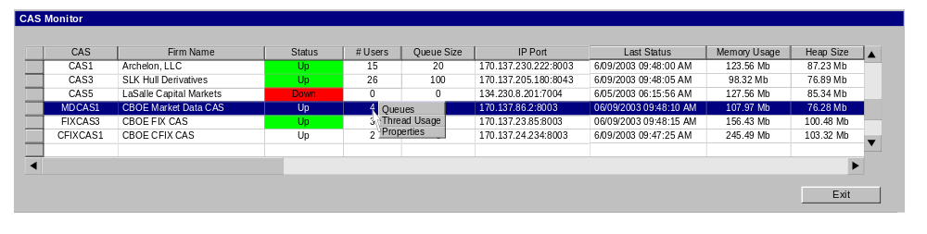CAS Monitor

From the CAS Status Monitor, Operations will be able to display the Queues, Thread Usage, and Properties of a specific CAS

Thread Usage
The CAS Monitor will allow Operations to display the CAS environment usage details.

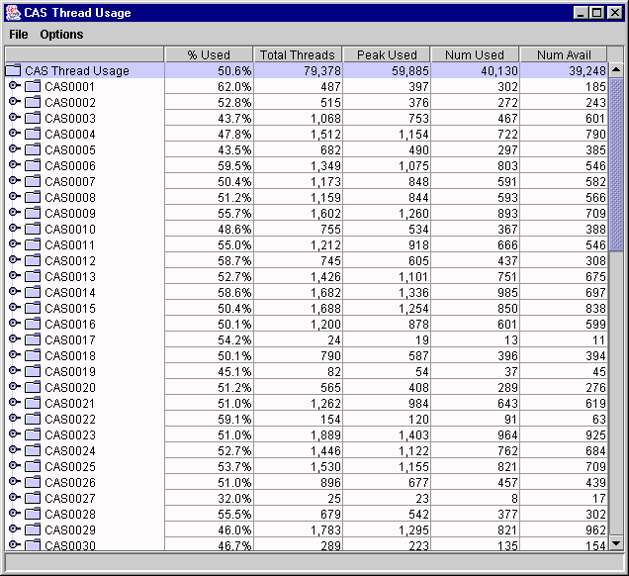CAS Thread Monitor

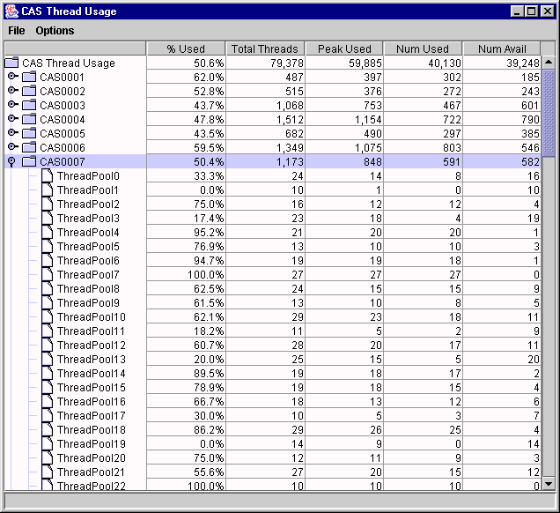
CAS Thread details

Display Current CAS Properties
The CAS Monitor will allow Operations to display all of the current runtime properties used in the CAS. These properties include, but may not be limited to:
- XML Configuration
- Command Line Arguments

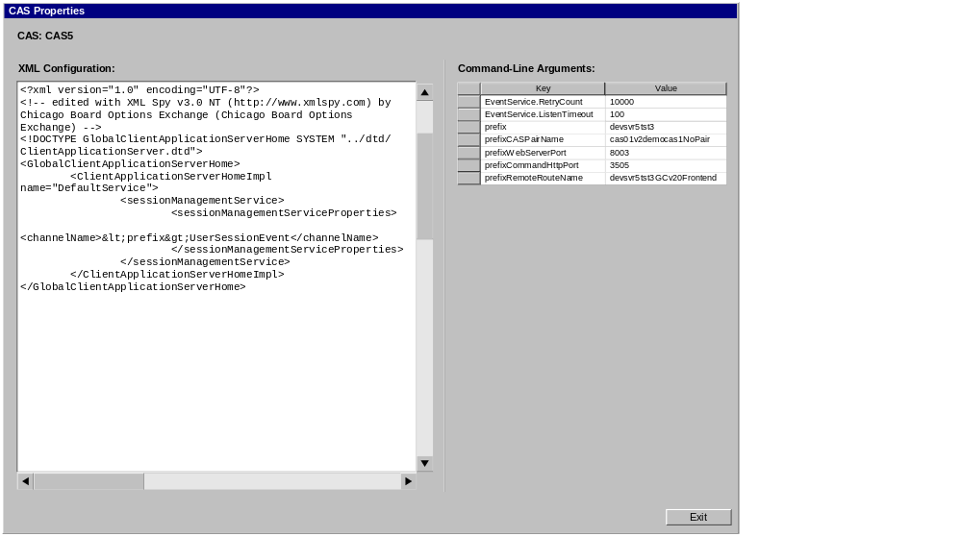

User Queue Monitor
The CAS Monitor will provide the means for Operations to request to view the current queues for a specific user session. Status will be provided for queues including, but not limited to, market data, order status and fill reports. By selecting queue status, Operations will be able to see the size of the largest current queue. Operations will also have the option to view the peak queue size for the day.

In the screen displayed below, the Peak Queue refers to the largest queue for the current business day. The User Queue Monitor will request queue details every n (2) minutes. The Max Current Queue Size will display the largest queue that existed at the time of the last refresh. The Current Max Callback refers to the name of the set of functions belonging to that largest queue.

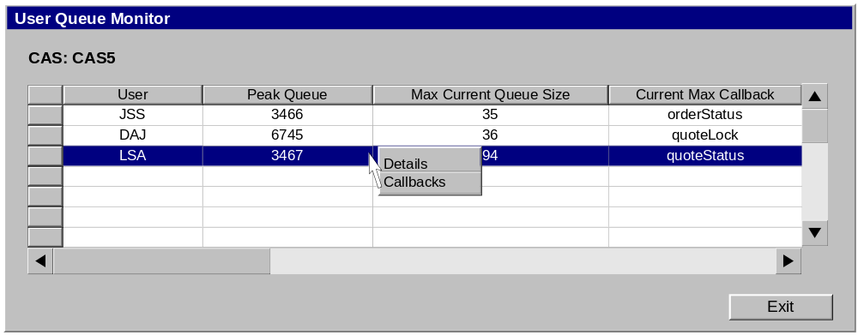
User Queue Monitor

User Callback Monitor
From the User Queue Monitor, Operations will be able to drill down to see the classes, class queue size and callback names for queuing messages that exist for that user.

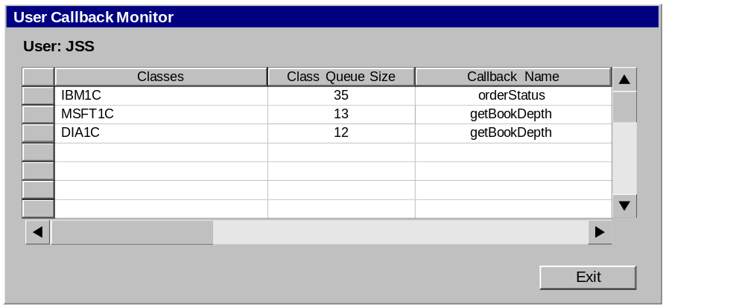

User Detail Monitor
The message flow monitor data will be provided at the User Session level.

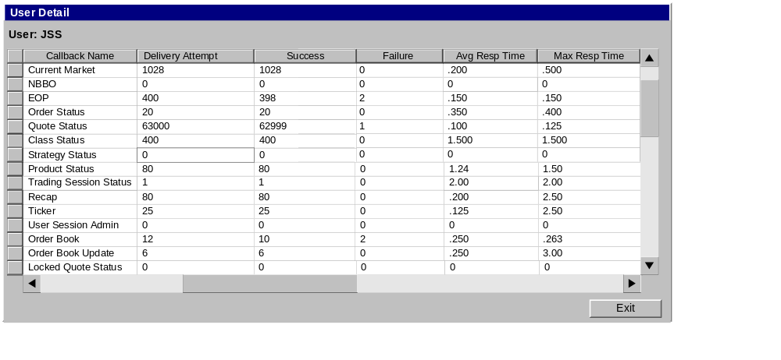 User Detail Monitor

Display Message Counts
Message counts will be provided for all of the CMi Callback messages. The GUI will display message counts for the following:

- Current Market
- NBBO
- Expected Opening Price
- Order Status
- Quote Status
- Class Status
- Strategy Status
- Product Status
- Trading Session Status
- Recap
- Ticker
- User Session Administration
- Order Book
- Order Book Update
- Locked Quote Status

Display message performance data
The User Detail Monitor will provide the means for Operations to view message performance data as well. The monitor will display performance statistics for a specific User on a CAS. These statistics would include the average response time for orders and the average response time for quotes, the maximum response time for orders and the maximum response time for quotes, and the standard deviation for orders and the standard deviation for quotes.

CAS Control
The initial implementation of CAS Monitor will be in a view only mode. In a later release, the CAS Monitor operating in Control Mode will allow Operations to perform CAS management functions. The following functions could be supported in a subsequent version of the CAS Monitor tool:
- Start CAS processes
- Re-initialize CAS processes
- Shutdown CAS processes
- Re-set runtime characteristics
- Re-set logging parameters
- Re-subscribe a set of users to a particular MD CAS.

SA GUI Enhancements

Display Orders

Currently, to display order status, the CBOE Help Desk selects “Orders” from the SA GUI User Management function. This causes the Orders tab to display. From this window, the CBOE Help Desk is able to view the status of orders for a particular user.

Users can be selected by CBOEdirect User ID, by Name or by Exchange/Acronym. Once a user is selected, the Help Desk must specify the product type, product class and product (contract month) from drop down list boxes. Currently, the list of orders for the selection criteria is displayed.

To enable the Help Desk to quickly locate orders that must be canceled, the Help Desk SA GUI and the CBOEdirect server will be enhanced to allow a Help Desk user to submit a cancel request to cancel all orders that match the selection criteria. In addition to searching order status by User, the following searches will be supported:

- Session
- Executing/Give-Up Firm
- Originator ID
- Subaccount Number
- Time-in-Force
- Class
- Product
- Product Type

The Help Desk should be able to select “All” for Product Class, Product, and Product Type. The Help Desk should also be able to select Orders by Time in Force: by all, by GTC or by Session.

This new enhancement will not display the orders to cancel. The Help Desk will be able to send a request to the server to cancel all orders that meet the selection criteria. Prior to the server executing the cancel request, the GUI will display an “are you sure” dialogue box that includes a list of the search criteria which will be canceled. The Help Desk will have the option to confirm the cancel request or cancel the action.
Both the Help Desk and the actual user should receive acknowledgements that the cancel request was successful.

Current functionality to display user orders by product type, product class and product will remain available to the Help Desk.

Cancel Event Logging Enhancements

The CME provides its users with a special identifier for orders canceled by the Globex Control Center. CME has asked OneChicago to support similar functionality when the CBOE Help Desk cancels its users orders. When the CBOE Help Desk cancels orders generated by the CME Globex Gateway, Help Desk should appear in the User Assigned Cancel ID field.

All Help Desk cancel activity must be electronically logged.

Trade Modification
Occasionally, errors in the market maker profile cause trades to be assigned to a clearing firm where the clearing will fail. When this occurs, the Help Desk requires a screen from which specific, authorized users can modify the trade. From this tool, the help desk will be able to search for a specific trade. Once the trade is selected, the Help Desk should be able to edit the executing/give-up firm and exchange and the market maker acronym and exchange. Price and quantity fields cannot be changed. Once the edit is saved, CBOEdirect should send CTM the modified trade. When this occurs, no new last sale should be disseminated via CFN. The trade history record should have an indication that the Help Desk modified the trade.

Trading Properties Screen
There are a number of configurable trading properties that are supported by CBOEdirect. Currently, when trading properties changes are requested, a member of the systems development staff edits the appropriate configuration file.

The SA GUI will be enhanced to provide a window for the Help Desk to display and edit all of the trading properties that CBOEdirect supports. These properties include:

Variable | Definition
Quote Response Time | The number of seconds allowed within which a Market Maker must provide a RFQ response to receive credit toward the RFQ response requirement.
Exchange Defined Width | The number of ticks between the bid and ask that meets the CBOE bid/ask spread requirement.
Minimum Quote Size | The number of contracts that a Market Maker must quote to receive credit toward the RFQ response requirement.
Continuous Market Time | The number of seconds during which a Market Maker must provide a quote in response to an RFQ in order to receive credit toward the RFQ response requirement.
Pre-opening Period | The number of minutes before the opening during which users may enter quotes and orders but no system processing occurs.
Opening Rotation | The number of seconds after the end of pre-opening I during which the system randomly sets the opening rotation.
EOP Display Time | The number of seconds after the start of the pre-opening after which the expected opening price is first calculated and displayed.
EOP Display Update | The interval, in seconds, by which the EOP is re-calculated and displayed.
Minimum Block Trade Size | The minimum quantity eligible to be executed outside CBOEdirect and reported as a Block Trade.
Dynamic Book Depth Display | The number of price levels deep updated dynamically in the book depth display.
Mandated Bust Request Time Limit | The number of minutes after a transaction made in error by which the error must be reported to the Help Desk for it to be eligible for mandated trade bust.
Reasonable Price Level Time Preceding | The number of minutes immediately preceding the placement of the order that generated the error trade.
Reasonable Price Level Time After | The number of minutes interval beginning n (30) seconds subsequent to the alleged erroneous execution.
Interval Start Time | The number of seconds after the alleged erroneous execution that begins the “Reasonable Price Level Time After”

Two additional functions will be added to the System Health Monitor window: a column that indicates Current Queues, where applicable, a column that displays the Last Update Time and a Refresh button at the bottom of the screen.
These windows will have the same look and feel of the System Health Monitor. There will be a tree view with each of the adapter services displayed beneath the adapter row.
Operations requested that the User Queue Monitor display the Sessions for which the user was active. Systems Development has determined that it would not be feasible to include that information in this particular display. Once the CAS Monitor has been implemented, Systems Development will work to integrate a subset of the CAS Monitor tools into the SA GUI.

